

**Department of Electrical Engineering**

**Faculty Member: Dr. Huma Ghafoor Dated: 9/03/2023**

**Course/Section: BEE 12 Semester: Spring 23 EE-351 Communication Systems**

**Lab 06: Mixer, IF Filter and Envelope Detector**

|  |  |  |  |  |  |  |
| --- | --- | --- | --- | --- | --- | --- |
|  | | **PLO4-CLO4** | | **PLO5- CLO5** | **PLO8- CLO6** | **PLO9- CLO7** |
| **Name** | **Reg. No** | **Viva / Quiz / Lab Performance** | **Analysis of data in Lab Report** | **Modern Tool Usage** | **Ethics and Safety** | **Individual and Team Work** |
| **5 Marks** | **5 Marks** | **5 Marks** | **5 Marks** | **5 Marks** |
| **Amina Bashir** | **343489** |  |  |  |  |  |
| **M. Ahmed Mohsin** | **333060** |  |  |  |  |  |
| **Syeda Fatima Zahra** | **334379** |  |  |  |  |  |
| **Hassan Rizwan** | **335753** |  |  |  |  |  |



Lab 6: Mixer, IF Filter and Envelope Detector

# Objectives:



When you have completed this exercise, you will be able to explain the operation of mixer, describe the function of IF filter and describe how the envelope detector converts a 455kHz signal to the message signal .You will use an oscilloscope to make AM signal measurements.

Introduction:

In this lab report, we focus on three key components in a communication system: the mixer, intermediate frequency (IF) filter, and envelope detector.

The mixer is a device that combines two input signals, typically a high frequency (RF) signal and a local oscillator (LO) signal, to produce a lower frequency output signal. This process is known as frequency conversion and is an essential step in many communication systems. The IF filter is used to select a specific frequency band from the mixed signal, which is then further processed. The envelope detector is used to extract the information from the modulated signal by detecting and recovering the envelope of the signal.

In this lab, we explore the behavior of these components and investigate how they contribute to the overall performance of a communication system. Specifically, we will study the characteristics of each component and how they affect the quality of the signal. We will also examine the effect of different parameters, such as the frequency and amplitude of the input signal, on the output signal.

PROCEDURE A:

Connect AM Transmitter Circuit and set the RF stage.

In this procedure, you will connect and adjust the Am transmitter. The transmitters output signal is used as the receivers input signal. You will adjust the RF stage.

1. Connect the AM transmitter circuit as shown.

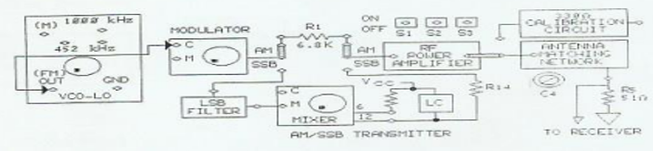

1. On the VCO-LO circuit block, insert the two-post connector in the 1000 kHz position.
2. Set switches S1 and S2 to OFF.
3. Set S3 to ON. When S3 is on, the ANTENNA MATCHING IMPEDANCE is automatically set to 33002.
4. Connect the oscilloscope channel 1 probe to the MODULATOR's carrier signal input (C).
5. While observing the signal on channel 1, set the carrier signal amplitude to 0.1 Vyu.pa by adjusting the knob on the VCO-LO circuit block.
6. While observing the signal on channel 1, set the carrier signal frequency to 1000 kHz by adjusting the NEGATIVE SUPPLY knob on the base unit.
7. Connect the oscilloscope channel 2 probe to the MODULATOR message signal input (M).
8. While observing the signal on oscilloscope channel 2. adjust the signal generator for a 0.1 Vu pi. 2 KHZ Sine wave signal at the message input of the MODULATOR.

1. Connect the channel 1 oscilloscope probe to the output of the antenna (RS). Set the sweep to 0.1 ms/DIV, and trigger on channel 2. Adjust the MODULATOR potentiometer knob so that the AM waveform is 100% modulated.

1. With a two-post connector. connect the TRANSMITTER to the 1 MQ resistor (R8) at the AM/SSB RECEIVER circuit block input.

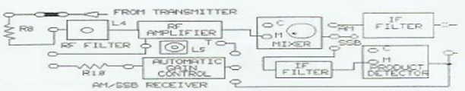

1. Connect the channel 1 oscilloscope probe to M at the MIXER. Adjust L5 at about the

midpoint so that a signal appears on channel 1.

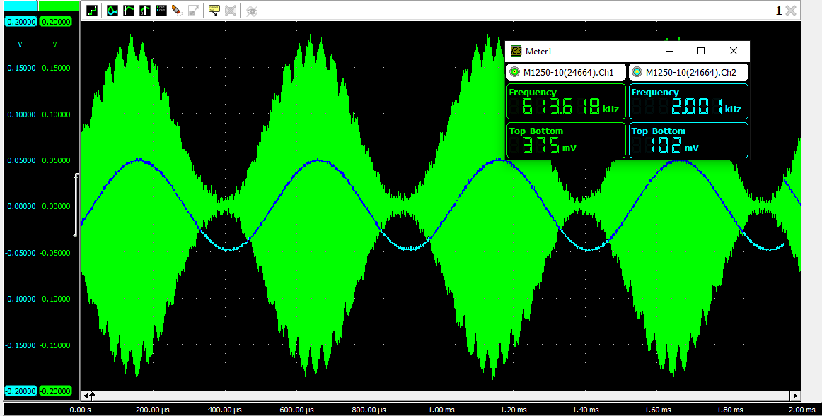

1. Tune inductor L4 for the maximum peak-to-peak AM signal at the RF AMPLIFIER output.
2. Adjust the variable inductor (L5) in the RF AMPLIFIER collector circuit for the maximum.

peak-to-peak AM signal at the RF AMPLIFIER output.

PROCEDURE B:

MIXER

1. As shown in Figure connect the output of the 1455 kHz VCO- Hi circuit block to the local

oscillator (C) input of the MIXER Set the VCO-HI potentiometer knob fully GW. Connect the

MIXER to the IF FILTER with a two-post connector.

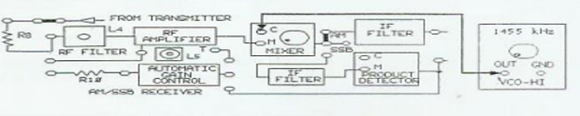

1. Connect the oscilloscope channel 2 probe to the MIXER'S output Adjust the MIXER'S balanced potentiometer knob until the output signal appears, as shown in Figure. This adjustment suppresses the 1455 kHz VCO-LO frequency in the output signal.

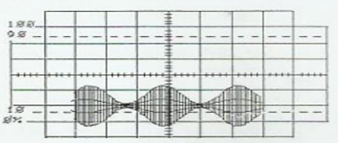

1. Connect the oscilloscope channel 2 probe to the output of the IF FILTER. While observing the IF FILTER output, set the 1455 kHz VCO-HI fraquency by adjusting the POSITIVE SUPPLY knob on the base unit for the maximum peak-to-peak signal. If this signal is not exact. the AM signal will not appear. Connect the oscilloscope channel 2 probe to the MIXER'S output. and connect the channel 1 probe to the MIXER'S M input.

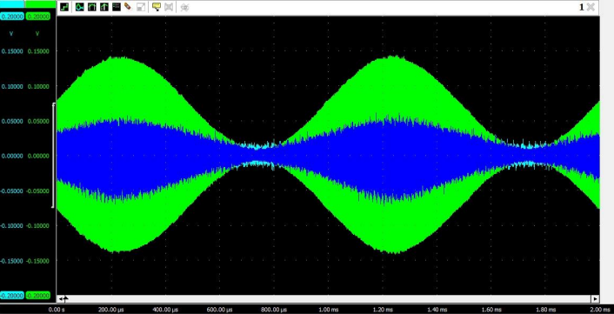

1. Adjust the MIXER'S potentiometer for a clear, sharp output signal. Compare the output signal on channel 2 with the MIXER'S input signal on channel 1. Is there another modulation envelope. Similar to the signal shown in Figure. within the AM signal at the MIXER output?

Yes, there is another modulation envelope observed.

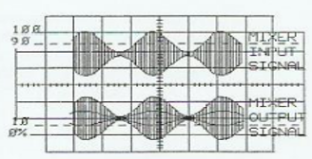

1. Set the oscilloscope swaap to 1 us/DIV, and trigger on channel 2. The MIXER'S output signal should be similar to the complex signal shown in Figure 3-26. Measure the time between peaks of the complex waveform, which is an approximate measure of the period (T). Each horizontal division is 1 us.

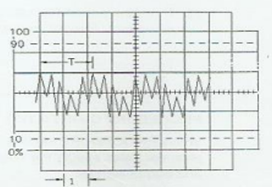

**T= 2 us**

1. From the period (T), calculate the frequency of the complex waveform (f = 1/7). Record your answer in kilohertz.

**F=**

1. To determine that frequencies in the range of 2455 kHz are present, set the oscilloscope sweep to 0 2us/DIV The signal on channel 2 should appear, as shown in Figure 3-27 Measure and

record the period (T). Each horizontal division is 0.2 us.

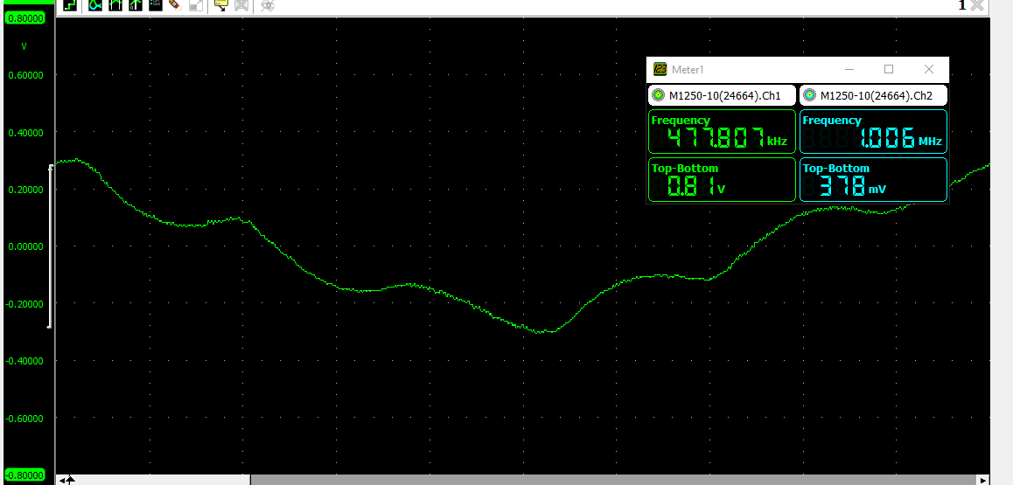

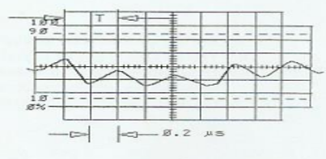

**T= 0.398 us**

1. From the period (T), calculate the frequency of the complex waveform. Record your answer in kilohertz.

**F=**

PROCEDURE C:

IF Filter

1. Connect the channel 1 oscilloscope probe to the IF Filter output. Channel 2 should be connected to the IF Filter input. Set the oscilloscope sweep to 0.2 ms/DIV. Trigger on channel 2.

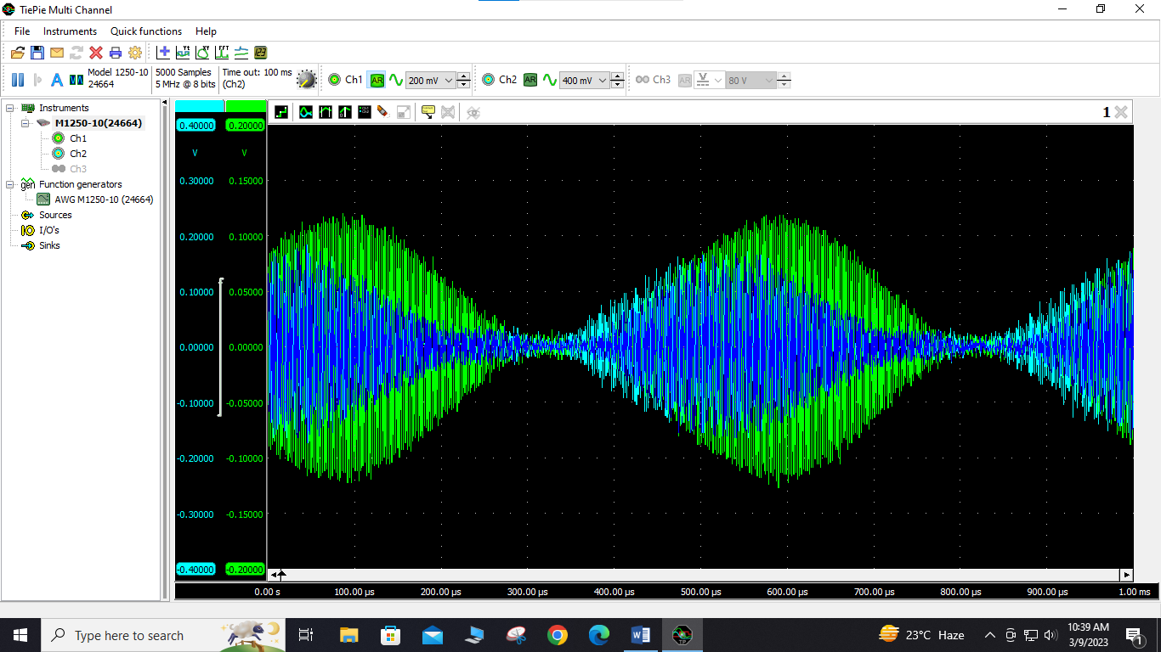

1. Compare the IF FILTER output on channel 1 with the IF FILTER input on channel 2. Is there another modulation envelope within the signal at the IF FILTER output?

1. While observing the IF FILTER output signal on channel 1. Slightly vary the frequency of the 1455 kHz signal to the MIXER by adjusting the POSITIVE SUPPLY fine tune knob on the base unit.

1. Why does the IF FILTER output signal disappear when the frequency of the 1455 kHz signal to the MIXER is slightly increased or decreased?

PROCEDURE D:

Envelope Detector

1. Connect the oscilloscope channel 1 probe to the MODULATOR message signal input on the AM/SSB TRANSMITTER circuit block and connect the channel 2 probe to the ENVELOPE DETECTOR output.
2. Does the signal at the ENVELOPE DETECTOR output have the same frequency as the message signal?

Yes, the ENEVELOPE DETECTOR output has approximately the same frequency as the message signal.

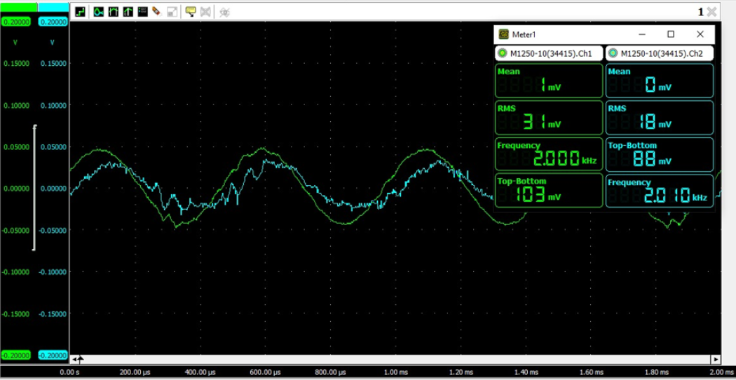

1. At the signal generator, vary the frequency of the 2 kHz message signal. Did the ENVELOPE DETECTOR output frequency vary with the frequency of the message signal.

Yes, as evident from the figure below, the ENVELOPE DETECTOR output frequency vary with the

frequency of the message signal



# Conclusion:

In conclusion, the experiments conducted to observe the functions of the mixer, envelope detector, and IF filter provided valuable insights into the practical aspects of these components in communication systems. Through our experiments, we were able to see the effects of each component on the signal and how they work together to ensure successful communication. We also observed how attenuation affects the signal and the importance of the IF filter in removing unwanted frequencies from the signal.

Our measurements and analysis confirmed the theoretical principles behind these components, and we were able to gain a deeper understanding of their functions and how they affect the signal. Overall, the experiments were successful in demonstrating the important role that the mixer, envelope detector, and IF filter play in communication systems and how attenuation affects the signal.